Cradlepoint Down
Verify Services with customer
CP Status
CP device down
Issue fixed

Offline
Call the carrier and Re-Sync the sim and advice customer to perform layer 1

Online
Dispatch Windstream FT
Issue persists

Verify the connection to the port and dispatch if necessary
Interface False

What is the interface status of the device it is connected to?
Verify the signal strength if you see the interface is true and reach out to the wireless carrier and get the SIM Re-Sync
Interface True
Advise customer to reboot the CP and check the cable connection between devices. Also verify the LED Status on the device. Bounce the port of the device the CP is connected to if needed.

The Interface status:

>Step 1: Log in to respective velo
>Step2: login to the VCE edge
>Step3: Check the Link status and check for the link for which the alarm is generated for
>Step 4: click on to Remote Diagnostics
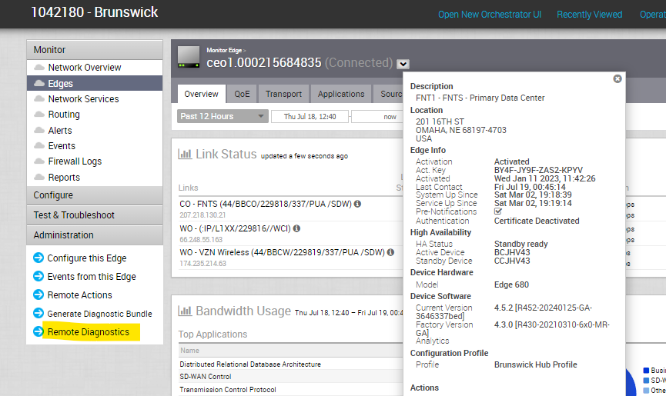
>Step 5: Select Interface status tab and click on RUN and search for the link which is down (Example: Link GE-6 Shows False)
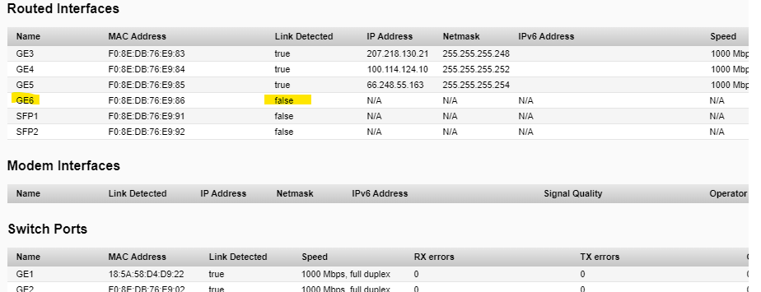

Cradle point Device Status:

Cradle point Online
Cradle point Offline
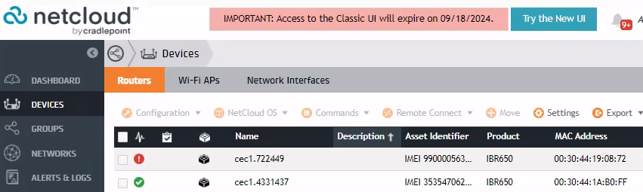

Cradle point Online::
Log into Netcloud: NetCloud by Cradlepoint (cradlepointecm.com)
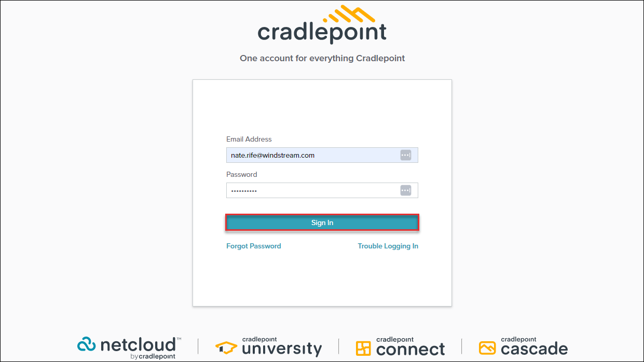
Locate the Cradle point device by using MDN,IMEI, Global Account number MAC address

If Cradle point is offline Engage Lec to Check if the SIM is Active or not and have the customer verify layer 1

If u can reach out to customer, please have them reboot, if the link is still showing down in velo, Check for interface status at velo cloud.
- If interface status is false | then cabling issue.

Port Bounce
- If interface status is true, then bounce the Port by NLS.
- Please do engage SIM carrier to check the status of SIM ( verify info with carrier as well )
- We can proceed with dispatch if above steps are taken care.

Locate the ip on cradle point
1: Search Using the Account number or device name -> if the graph shows Green it means the CP is UP for the customer
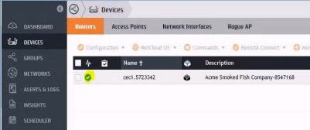
2: Select the Configuration drop box, click on EDIT
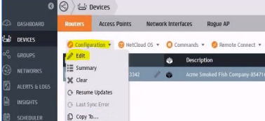

3: Go to Networking on the left-hand side -> Local IP Network,
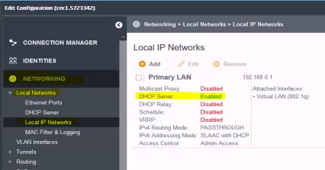
4: Select the Primary LAN -> click on Edit
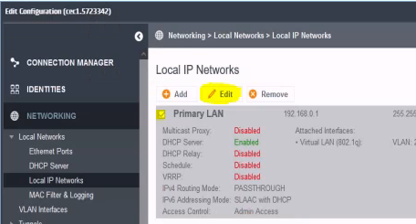
5: Select the Enable DHCP Server -> and click Save
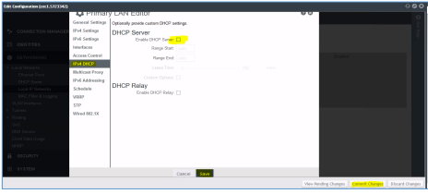
6: Once saved click on Commit changes. Now DHCP server will be enabled

Perform VRA if possible with customer or use the below template and customize the email as per requirement.

Cradle point/BEC/Cisco Wireless down (Connected to SDWAN/VELO)

Dear Customer,

This email is regarding a proactive repair case no 04321623, created for the (business name), located at (service address), stating a port on the (SDWAN/VELO) device is down.

We see the (Cradle point/BEC/Cisco Wireless) device connected to port (GE 1/GE 2/GE 3/SFP 1/SFP 2) of the (SDWAN/VELO) device is down, which is your (Primary/Secondary/Backup) connection however, your services are running on the (Primary/Secondary/Backup) connection.

We request you to follow the below troubleshooting and update us with the info listed below so that we can proceed with further troubleshooting and restore the connection.

1. Unplug the cable connected to the (Cradle point/BEC/Cisco Wireless) device going to the port (GE 1/GE 2/GE 3/SFP 1/SFP 2) of the (SDWAN/VELO)

2. Unplug the cable connected to the port (GE 1/GE 2/GE 3/SFP 1/SFP 2) of the (SDWAN/VELO)
Important Note: Please DO NOT reboot or unplug the (SDWAN/VELO) device from the power source.

3. Disconnect the (Cradle point/BEC/Cisco Wireless) device from the power source and reconnect after 10 to 15 seconds

4. Once the (Cradle point/BEC/Cisco Wireless) device reboots, plug the cable into the same port of the (SDWAN/VELO) device and (Cradle point/BEC/Cisco Wireless) to restore the connection.

5. Please check the light on the equipment and the port once the reboot is done
If you have any queries, please reach us directly at 1800-600-5050 Option 1 or reply to this email.

You can also check for updates on the We-Connect portal through the link mentioned below.
Link: https://we.windstream.com

We are always here and happy to assist you.
Regards,
Windstream repair

Cradlepoint/BEC/Cisco Wireless Down (Connected to SDWAN/VELO) 2nd Email Follow up

This is a follow up email regarding the proactive repair case number 04321623, created for the (business name), located at (service address), stating the (Cradlepoint/BEC/Cisco Wireless) device connected to port (GE 1/GE 2/GE 3/SFP 1/SFP 2) of the (SDWAN/VELO) device is down.
This is a reminder on the email we had sent earlier to check the cable connections and perform a reboot however, we haven’t received any update yet.
We request you to kindly reboot the connection as per the initial email request and update us so we can troubleshoot further to restore the service/connection.
In case you are facing issues identifying the device, perform a reboot or are not sure how to check a device status, we also provide assistance via below available platform to make it a hassle free experience.
- Virtual remote assistance (Guidance on video call by technician)
To know more about how to get access to Virtual Remote Assistance or any other queries related to this ticket, please reach us directly at 1800-600-5050 Option 1 or reply to this email.
You can also check for updates on the We-Connect portal through the link mentioned below.
Link: https://we.windstream.com
We are always here and happy to assist you.
Regards,
Windstream Repair

Cradlepoint/BEC/Cisco Wireless Down (Connected to SDWAN/VELO) 3rd Email Follow up

Dear Customer,
We are still waiting for your confirmation on the proactive repair case number 04321623, created for the (business name), located at (service address), stating the (Cradlepoint/BEC/Cisco Wireless) device connected to port (GE 1/GE 2/GE 3/SFP 1/SFP 2) of the (SDWAN/VELO) device is down.
We have not received any update yet and would like to know if you can provide us an additional contact we can work with to get the device and cables checked at the above mentioned service location.
Please provide the contact details as below
Name:
Phone Number:
Email Address:
If you have any queries, please reach us directly at 1800-600-5050 Option 1 or reply to this email.
You can also check for updates on the We-Connect portal through the link mentioned below.
Link: https://we.windstream.com
We are always here and happy to assist you.
Regards,
Windstream Repair

